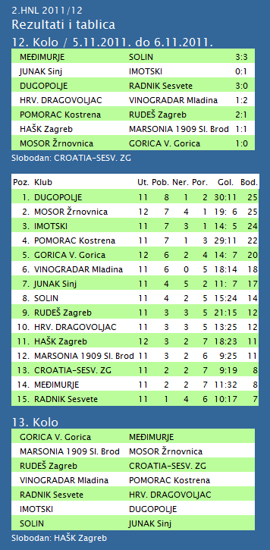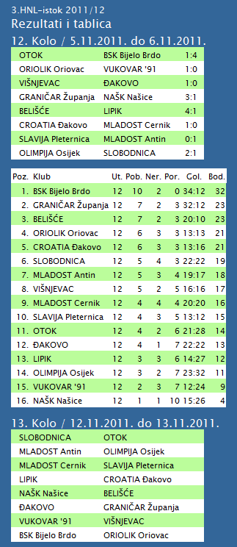
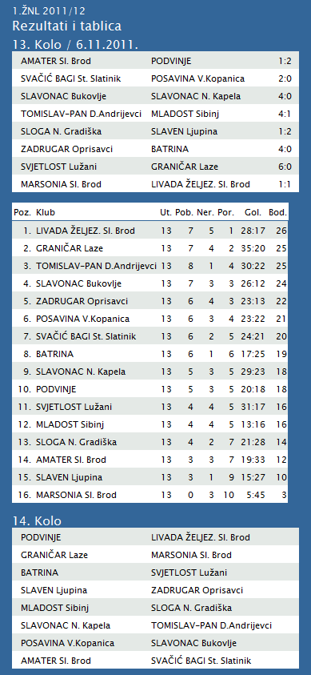
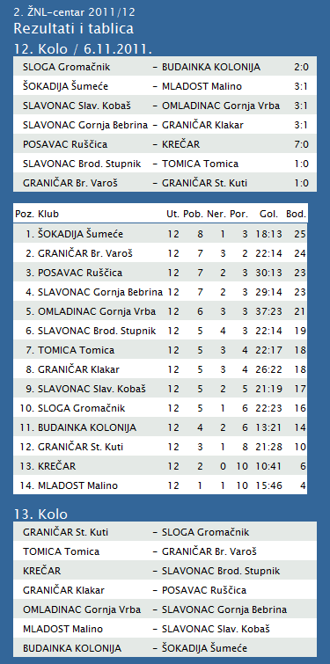
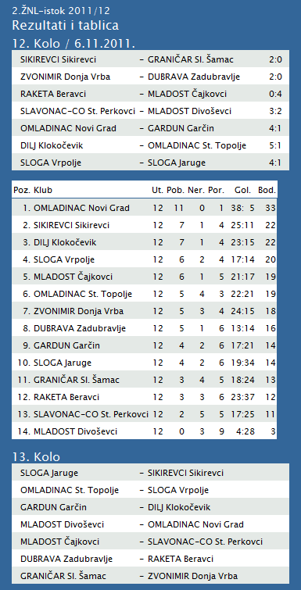
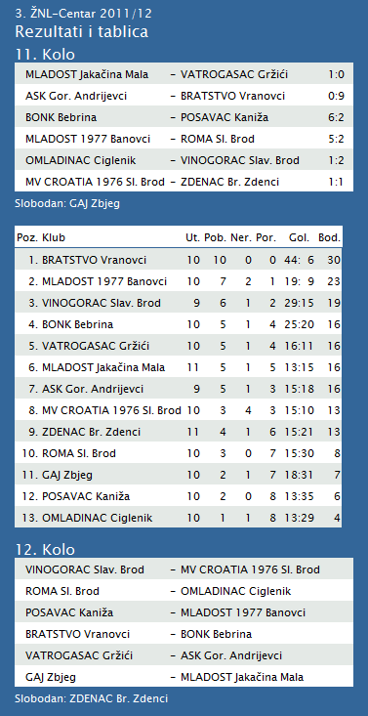

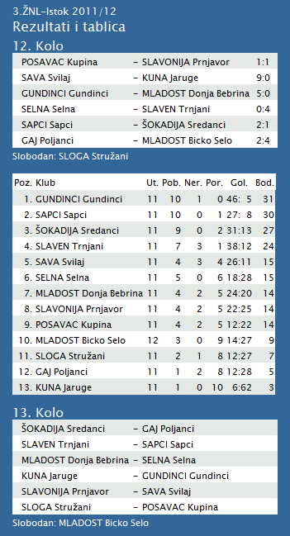
TABLICA A1 MUŠKA LIGA
# |  | Klub | W | L | Bod | Omjer |  |  | Razlika
 | 1 | KK Križevci (-15) | 4 | 1 | 9 | 447 | : | 432 | 15
 | 2 | KK Split (-15) | 4 | 1 | 9 | 412 | : | 379 | 33
 | 3 | KK Jolly JBS (-15) | 3 | 2 | 8 | 388 | : | 368 | 20
 | 4 | KK Kvarner 2010 (-15) | 3 | 2 | 8 | 402 | : | 412 | -10
 | 5 | KK Zadar (-16) | 3 | 1 | 7 | 297 | : | 252 | 45
 | 6 | KK Sonik-Puntamika (-15) | 2 | 3 | 7 | 371 | : | 352 | 19
 | 7 | KK Zabok (-16) | 2 | 2 | 6 | 314 | : | 317 | -3
 | 8 | KK Brod Svjetlost (-16) | 2 | 2 | 6 | 288 | : | 302 | -14
 | 9 | KK Alkar (-16) | 1 | 3 | 5 | 282 | : | 304 | -22
 | 10 | KK Vrijednosnice OS Darda (-16) | 1 | 3 | 5 | 291 | : | 314 | -23
 | 11 | KK Dubrovnik (-15) | 0 | 5 | 5 | 387 | : | 447 | -60
1. HRL muški

Ukupni rezultati:
 |  | U | P | N | P | DP | BOD.
1. | VIDOVEC-BIOS | 9 | 7 | 1 | 1 | 272:218 | 15
2. | DUGO SELO | 9 | 6 | 1 | 2 | 299:275 | 13
3. | MEDVEŠČAK NFD | 9 | 6 | 1 | 2 | 258:236 | 13
4. | MOSLAVINA | 9 | 6 | 0 | 3 | 253:237 | 12
5. | SENJ-WALLENBORN | 9 | 5 | 1 | 3 | 265:258 | 11
6. | OSIJEK | 9 | 5 | 0 | 4 | 278:273 | 10
7. | ĐAKOVO | 9 | 5 | 0 | 4 | 257:252 | 10
8. | MLADI RUDAR | 9 | 4 | 1 | 4 | 239:243 | 9
9. | UMAG | 9 | 3 | 2 | 4 | 254:252 | 8
10. | ŽUPANJA | 9 | 4 | 0 | 5 | 235:247 | 8
11. | CRIKVENICA | 9 | 3 | 0 | 6 | 229:255 | 6
12. | IVANČICA IVANEC | 9 | 2 | 0 | 7 | 264:280 | 4
13. | BROD | 9 | 2 | 0 | 7 | 233:272 | 4
14. | BIOGRAD | 9 | 1 | 1 | 7 | 239:277 | 3
2. HRL sjever žene

Ukupni rezultati:
 |  | U | P | N | P | DP | BOD.
1. | OSIJEK PSC | 7 | 7 | 0 | 0 | 226:123 | 14
2. | PETRIJEVCI | 7 | 6 | 0 | 1 | 254:218 | 12
3. | BJELOVAR | 7 | 5 | 1 | 1 | 209:201 | 11
4. | ZRINSKI | 7 | 4 | 1 | 2 | 208:195 | 9
5. | PODRAVKA-LINO | 7 | 3 | 1 | 3 | 209:201 | 7
6. | BROD-GYMNASIUM | 7 | 3 | 1 | 3 | 178:173 | 7
7. | PITOMAČA | 7 | 3 | 1 | 3 | 197:215 | 7
8. | ĐURĐEVAC | 7 | 3 | 0 | 4 | 203:207 | 6
9. | DARDA | 7 | 2 | 0 | 5 | 200:220 | 4
10. | CERNA | 7 | 2 | 0 | 5 | 165:202 | 4
11. | VUKOVAR | 7 | 1 | 0 | 6 | 163:204 | 2
12. | IVANEC | 7 | 0 | 1 | 6 | 187:240 | 1

